DOCUMENTATION
*Abstract*
The Number Puzzle Game with Scoreboard is a simple game where the user has to guess a randomly generated number. The game keeps track of the user’s score, which is the number of attempts it takes to guess the number. The scoreboard is saved to a file, allowing users to view their previous scores.

*Introduction*
The Number Puzzle Game with Scoreboard is a fun and challenging game that tests the user’s guessing skills. The game generates a random number between 1 and 100, and the user has to guess the number by suggesting possible values. After each guess, the game provides feedback in the form of “too high” or “too low” to help the user narrow down the possible range. The game continues until the user guesses the number correctly.

*Software Requirements*
- Operating System: Windows or Linux
- Programming Language: C
- Compiler: GCC
- Development Environment: Any text editor or IDE

*Hardware Requirements*
- Processor: Any processor with a C compiler
- RAM: 256 MB or more
- Storage: 10 MB or more

*Code*
#include <stdio.h>
#include <stdlib.h>
#include <time.h>

#define MAX_SCORES 10
#define FILE_NAME "scoreboard.txt"

typedef struct {
char name[50];
int score;
} Score;

void displayMenu() {
printf("Number Puzzle Game\n");
printf("1. Play Game\n");
printf("2. View Scoreboard\n");
printf("3. Exit\n");
}

void playGame() {
int numberToGuess = rand() % 100 + 1;
int attempts = 0;
int guess;

printf("Guess a number between 1 and 100\n");

while (1) {
printf("Enter your guess: ");
scanf("%d", &guess);
attempts++;

if (guess < numberToGuess) {
printf("Too low\n");
} else if (guess > numberToGuess) {
printf("Too high\n");
} else {
printf("Congratulations! You guessed the number in %d attempts\n", attempts);
return;
}
}
}

void saveScore(char *name, int score) {
FILE *file = fopen(FILE_NAME, "a");
if (file == NULL) {
printf("Error opening file\n");
return;
}

fprintf(file, "%s %d\n", name, score);
fclose(file);
}

void viewScoreboard() {
FILE *file = fopen(FILE_NAME, "r");
if (file == NULL) {
printf("No scores yet\n");
return;
}

Score scores[MAX_SCORES];
int scoreCount = 0;

while (fscanf(file, "%s %d", scores[scoreCount].name, &scores[scoreCount].score) == 2) {
scoreCount++;
if (scoreCount >= MAX_SCORES) {
break;
}
}

fclose(file);

// Sort scores in ascending order
for (int i = 0; i < scoreCount - 1; i++) {
for (int j = i + 1; j < scoreCount; j++) {
if (scores[i].score > scores[j].score) {
Score temp = scores[i];
scores[i] = scores[j];
scores[j] = temp;
}
}
}

printf("Scoreboard:\n");
for (int i = 0; i < scoreCount; i++) {
printf("%d. %s - %d attempts\n", i + 1, scores[i].name, scores[i].score);
}
}

int main() {
srand(time(NULL));

while (1) {
displayMenu();
int choice;
printf("Enter your choice: ");
scanf("%d", &choice);

switch (choice) {
case 1: {
playGame();
char name[50];
printf("Enter your name: ");
scanf("%s", name);
int attempts;
printf("Enter number of attempts: ");
scanf("%d", &attempts);
saveScore(name, attempts);
break;
}
case 2:
viewScoreboard();
break;
case 3:
return 0;
default:
printf("Invalid choice\n");
}
}

return 0;
}

*Result*
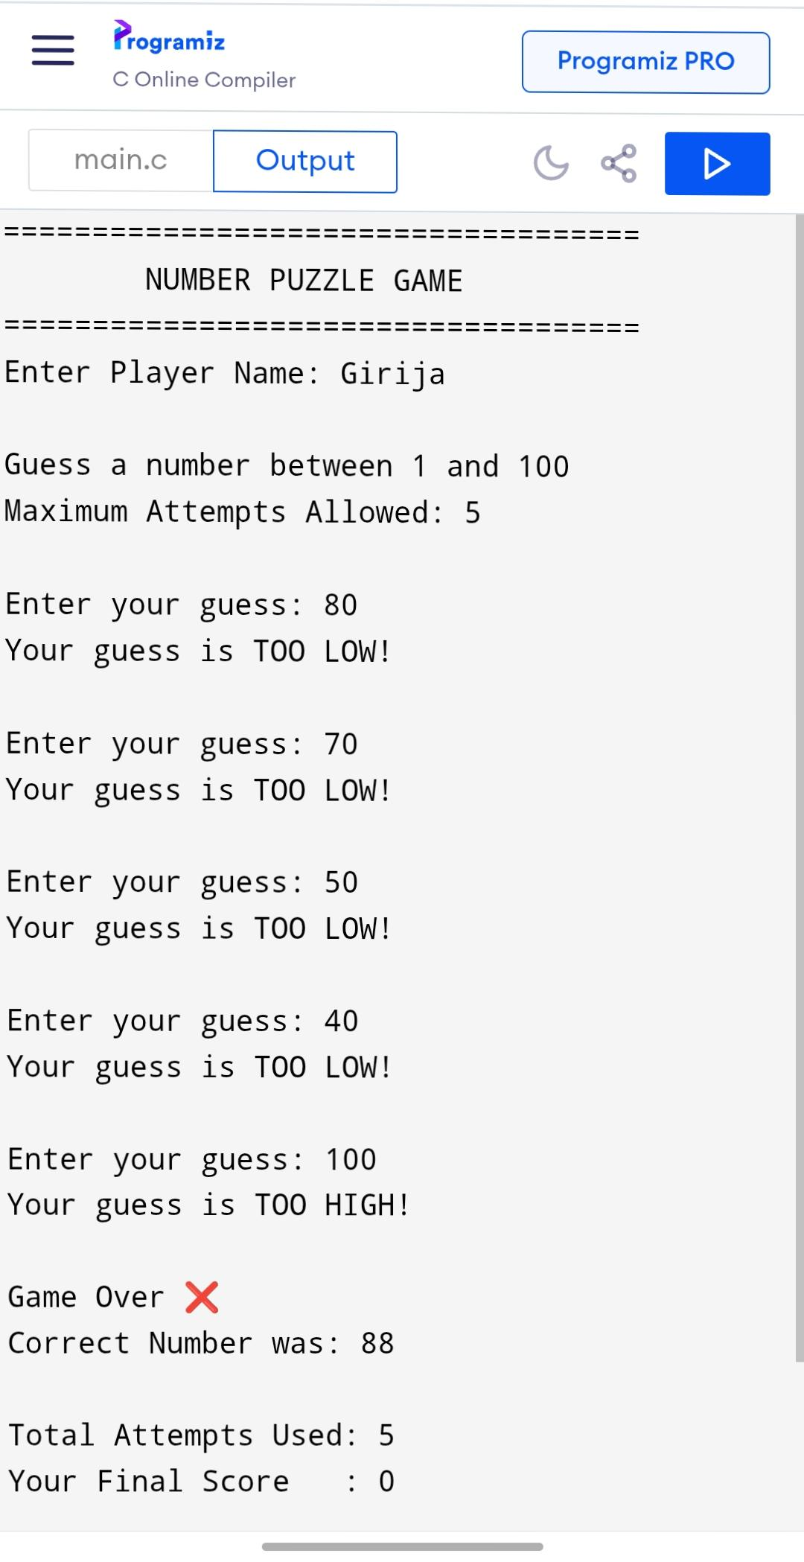
*Result*

*Conclusion*

The Number Puzzle Game with Scoreboard is a fun and challenging game that tests the user’s guessing skills. The game is simple to play, and the scoreboard feature adds an extra level of excitement by allowing users to track their progress. The game can be further improved by adding more features, such as different difficulty levels or a timer.

